KENDRIYA VIDYALAYA NO.2 BAILEY ROAD PATNA
BEST PERFORMERS
Sl. No. | STUDENT NAME |  | CLASS/SEC | SHIFT | CONTACT NO. | EMAIL | FIELD OF ACHIEVEMENT | PHOTOGRAPH
 |  | GAMES ANS SPORTS
01 | ABHISHEK KUMAR |  | 10C | 1ST | 8434759344 | rjabhishek2016@gmail.com | KHELO INDIA (MALLKHAM) | 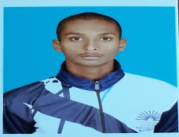
02 | KUMARI SUPRIYA |  | 9C | 1ST | 7061540083 | Supriyakri2032008@gmail.com | OPEN NATIONAL (YOGA) | 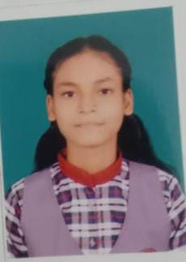
03 | LAXMI KUMARI |  | 9A | 1ST | 9113128458 | rajeshmandal3110@gmail.com | OPEN NATIONAL (YOGA) | 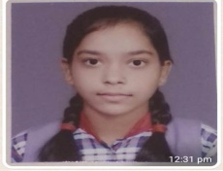
04 | ANJALI KUMARI |  | 9C | 1ST | 7979871415 | anjalikri13102006@gmail.com | KHELO INDIA (MALLKHAM) | 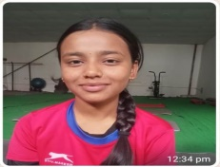
05 | SARTHAK |  | 7B | 1ST | 9113385644 | priyankasingh54933@gmail.com | KHELO INDIA (MALLKHAM) | 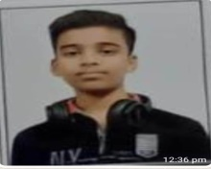
06 | DHANANJAU KUMAR |  | 10C | 1ST | 8051169265 | dhananjaykumar00880@gmail.com | KHELO INDIA (MALLKHAM) | 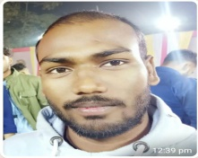
07 | ABHIMANYU |  | 7C | 2ND | 930431467 | renudeviji9777@gmail.com | KHELO INDIA (MALLKHAM) | 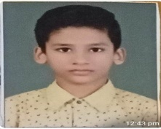
ACADEMICS
01 | SATYAM CHITRANSH |  | 12B | 1ST | 8084529442 | chitranshair@gmail.com | JEE ADV.  AIR 602 | 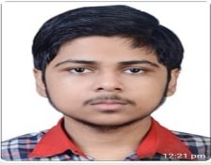
02 | VISHRUTA SINHA |  | 12A | 1ST | 9693734499 | sinhavishruta@gmail.com | NEET 2021  AIR 5932 | 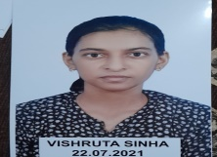
03 | PIYUSH KUMAR |  | 12C | 1ST | 7759861425 | Piyushkumarmark2@gmail.com | NTSC  QUALIFIED FOR 2ND LEVEL | 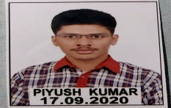
04 | SHRUTIPARNA BASAK |  | 10D | 1ST | 7870246203 | mithisrutiparna123@gmail.com | NTSC  STATE TOPPER (GILRS) | 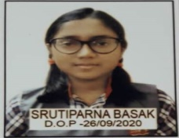
05 | UTKARSH ANAND |  | 10D | 1ST | 9430893744 | Jp12071972@gmail.com | NTSC  QUALIFIED FOR 2ND LEVEL
BPSC
01 | MD. ZEESHAN ARIF |  | 12B | 1ST | 8002528838 | zeeshanarif260@gmail.com | 65TH BPSC  CLEARED
02 | RASHMI RANI |  | 12B | 1ST | 9631501249 | Rashmibit6694@gmail.com | UPSC 2020 CLEARED  RANK 457 | 